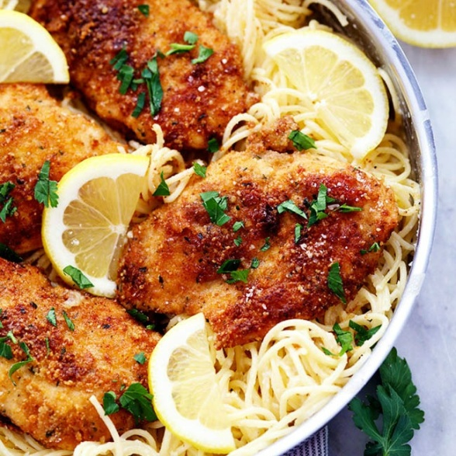
Crispy Parmesan Chicken with Creamy Lemon Garlic Pasta

Prep time 15 mins Cook time 15 mins
4 Servings
Ingredients
2 chicken breasts
6 tbsp butter, divided
½ cup Italian breadcrumbs
½ cup grated parmesan
¼ cup flour
8 oz pasta of choice
½ cup heavy whipping cream
½ cup grated parmesan cheese
Juice of one lemon
1 tsp garlic powder
½ tsp salt
¼ tsp pepper
Directions
- Melt 4 tablespoons of butter in a shallow dish. In another shallow dish combine breadcrumbs, parmesan cheese, and flour. Dip the chicken in the butter and then coat in the bread crumb mixture and place in skillet.
- In a large skillet over medium heat melt 2 tablespoons butter. Cook on each side for about 3 to 4 minutes until the outside is crispy and the chicken is cooked throughout.
- Meanwhile, cook the pasta according to package directions and drain.
- In a medium sized skillet add the heavy whipping cream, parmesan cheese, lemon juice, garlic powder, salt and pepper. Whisk together and cook over medium high heat until it starts to thicken. Remove from heat and add the pasta to coat in the sauce.
- Serve the chicken with the pasta

Notes
For individual portion packs, use four chicken breasts.
Mom and Heather recommend doubling the sauce.

